# UAV for mapping and remote sensing concerning Principle-6

**Project Director**

Md Sharif Hossain

ID: 1712336642

EEE 452

Sec: 01



**Submitted to:**

M. Rokonuzzaman, PhD

Department of Electrical and Computer Engineering

North South University

Bashundhara, Dhaka

Date: 5th April 2020

Introduction: In this term paper, I’ll interpret a given principle of innovation within the context of a chosen area of innovation.

The given principle of mine was principal-6 which says that “*To counter the downward trend of willingness to pay caused by competition force and to create higher willingness to pay among the growing number of customers, improved versions (by improving existing featured and/or adding new features) of the product should be kept releasing.*

*As a result, a great idea needs a flow of ideas and continued growth of technologies to implement them to empower the initial idea to generate profitable revenue. In the absence of this flow, often the startup around the initial great idea leads to failure in creating new wealth and generating profitable revenue.*”

Again, the chosen area of innovation was: “*UAV for mapping and remote sensing*”. In this term paper, I’ll interpret this principle of innovation within the context of this topic.

# What is UAV?

Unmanned aerial vehicles (UAV) are a class of aircraft that can fly without the onboard presence of pilots. Unmanned aircraft systems consist of the aircraft component, sensor payloads and a ground control station. They can be controlled by onboard electronic equipment or via control equipment from the ground. When it is remotely controlled from the ground it is called RPV or Remotely Piloted Vehicle and requires reliable wireless communication for control. Dedicated control systems may be devoted to large UAVs, and can be mounted aboard vehicles or in trailers to enable proximity to UAVs that are limited by range or communication capabilities.[1] An unmanned aerial vehicle (UAV) is commonly known as a drone.

# How Drones Work?

A typical unmanned aircraft is made of light composite materials to reduce weight and increase maneuverability. This composite material strength allows military drones to cruise at extremely high altitudes.

Drones are equipped with different state of the art technology such as infrared cameras, GPS and laser (consumer, commercial and military UAV). Drones are controlled by remote ground control systems (GSC) and also referred to as a ground cockpit.

An unmanned aerial vehicle system has two parts, the drone itself and the control system.

The nose of the unmanned aerial vehicle is where all the sensors and navigational systems are present. The rest of the body is full of drone technology systems since there is no space required to accommodate humans.

The engineering materials used to build the drone are highly complex composites designed to absorb vibration, which decreases the sound produced. These materials are very lightweight.[2] From the very beginning, UAV or Drones were mainly used for military purposes. Nowadays, there is a growing market of Drones for civilians.

UAV market for Civilians: The civilian drone market is dominated by Chinese companies. Chinese drone manufacturer DJI alone has 74% of civilian-market share in 2018 with $11 billion forecast global sales in 2020.[3] DJI is followed by Chinese company Yuneec, US company 3DRobotics and French company Parrot with a significant gap in market share.[4] As of March 2018, more than one million UAVs (878,000 hobbyists and 122,000 commercial) were registered with the U.S. FAA. 2018 NPD point to consumers increasingly purchasing drones with more advanced features with 33 percent growth in both the $500+ and $1000+ market segments.[5]

The civilian UAV market is relatively new compared to the military one. Companies are emerging in both developed and developing nations at the same time. Many early-stage startups have received support and funding from investors as is the case in the United States and by government agencies as is the case in India.[6] Some universities offer research and training programs or degrees.[7]

The global UAV market will reach US$21.47 billion, with the Indian market touching the US$885.7 million mark, by 2021.[8]

Lighted drones are beginning to be used in nighttime displays for artistic and advertising purposes.

The use of UAV for Remote Sensing and Mapping: Unmanned aerial vehicles equipped with digital compact cameras can be used to map landslides quickly and at a high ground resolution. Images taken by a radio-controlled mini quad-rotor UAV of the Super-Sause, France landslide have been used to produce a high-resolution ortho-mosaic of the entire landslide and digital terrain models of several regions.[9]

4. UAVs Remote Sensing Applications

The European Commission listed a set of civil and commercial applications of UAVs and categorized them as (a) Government (civil security, border security, and coastguard); (b) Fire Fighting (forest ﬁre spotting and coordination, major incident response co-ordination, and emergency rescue); (c) Energy Sector (oil and gas industry distribution infrastructure, electricity grids, and distribution networks); (d) Agriculture Forestry and Fisheries (environmental monitoring, crop dusting, and optimizing the use of resources); (e) Earth Observation and RS (climate monitoring, aerial

photography, mapping and surveying, seismic events, major incident, and pollution monitoring); (f) Communications and Broadcasting (Very High Altitude, Long-Endurance (VHALE) platforms as proxy satellites, medium-altitude Long-Endurance (MALE) UAVs for communication coverage, and camera platforms). [10]

Basic concept on Sustaining Innovation of UAV for mapping and remote sensing in a Competitive Market: An Innovative idea is not enough to get succeeded in a competitive market. It needs a flow of ideas as a continuous innovative push to make and keep it successful. According to Dr. Rokonuzzaman, an academic and Researcher in Technology and Innovation, the new ideas or upgrades should have the ability to increase the quality (Q) and reduce the cost (C) simultaneously. There could be four different combinations of these important variables as shown in Figure 1.

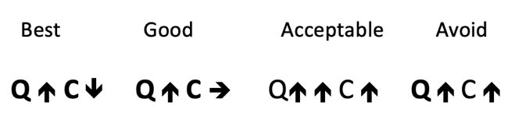Figure 1: Four different plausible scenarios[11]

There are four plausible scenarios. The Best one is that producer succeeds in improving the quality and reducing the cost simultaneously. The next one is the situation when quality goes up but the cost does not, could be termed as Good achievement. While the quality goes up far more than the cost increase could be termed as an acceptable option. All other options must be avoided in the journey of crafting sustainable means of improving both consumer and producer surpluses simultaneously.

The researcher also added in his report titled “Succeeding with innovation in a globally connected competitive market economy” that, “Once an innovative product starts showing the possibility of profitability and growth, it starts experiencing two major forces: 1. Competition, and 2. Externality effect. The competition force shows up in the form of (i) Replication, (ii) Imitation, (iii) Innovation, and (iv) Substitution at a later stage. The externality effect comprises of (i) Complementary offering products from 3rd parties, (ii) Network effect, and (iii) Information and experience effect. The competition force affects the willingness to pay (WtoP) of the product negatively, drifting it downward. On the other hand, the externality effect plays a positive role. For example, due to the offering of complementary products from 3rd parties, the perceived value of the innovation keeps going up, affecting *WtoP* positively. Similarly, the network effect keeps increasing the value of the product with the growth of the customer base of the product. On the other hand, once the information gap about the utility of the product is reduced and potential customers get a chance to experience the product, the *WtoP* increases.”

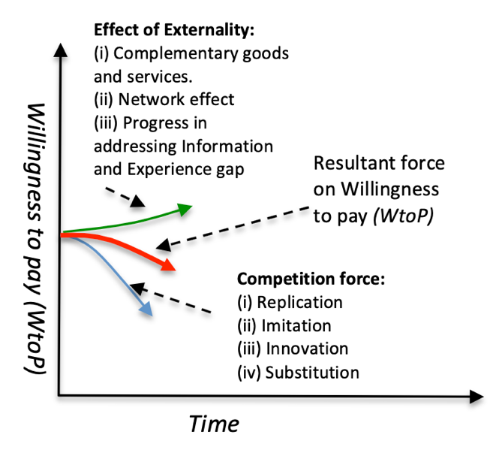

Figure 2: In a competitive market, *WtoP* of an innovative product keeps drifting downward.

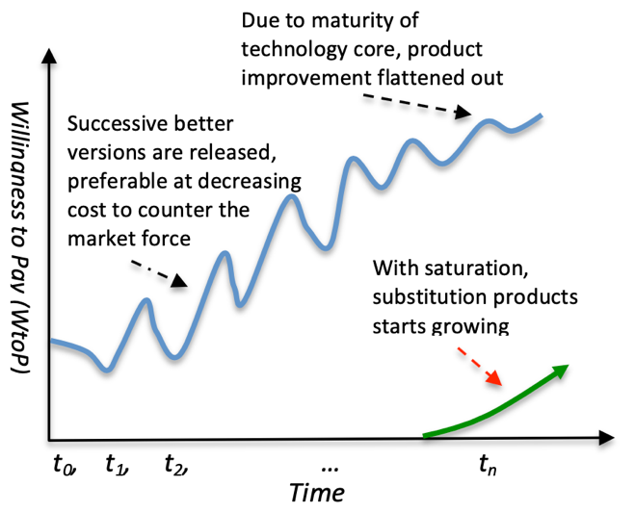

Figure 3: To counter the drifting WtoP, the innovator keeps releasing successive better version

As we can see, the WtoP to an innovative product keeps drifting downward as time progresses as shown in Fig.2. A continuous upgrade can make the curve upward.

As an example, consider the following graph (Figure: 4) of the smartphone industry. All of the industries faced a downward drifting curve. Which companies kept upgrading the devices, could increase the sales. Others resulted in destruction.

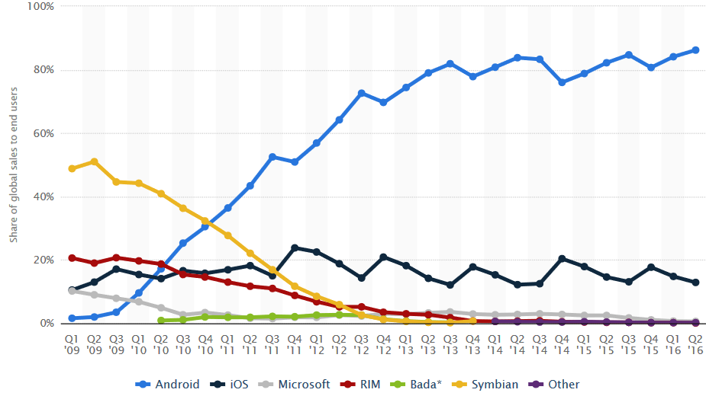

Figure 4: Change in market shares in smartphone industries[12]

Discussion: UAV technology is a growing innovative technology. It is still in the segment of early adopters. This technology needs more innovative ideas to get succeeded.

1. Ram Gopal Lakshmi Narayanan, Oliver C. Ibe, in Wireless Public Safety Networks, “Joint Network for Disaster Relief and Search and Rescue Network Operations”, 2015
2. Fintan Corrigan, “How Do Drones Work And What Is Drone Technology", March 26, 2020
3. Bateman, Joshua (1 September 2017). "China drone maker DJI: Alone atop the unmanned skies". *News Ledge*.
4. "Dijk market share: here's exactly how rapidly it has grown in just a few years". *Embrey blog*. 
5. "Consumer Drones by the Numbers in 2018 and Beyond | News Ledge". *News Ledge*. 4 April 2017. Retrieved 13 October 2018.
6. Skylark Drones set to raise its first round of funding to boost expansion". 14 September 2015. Retrieved 28 August 2016
7. Peterson, Andrea (19 August 2013). "States are competing to be the Silicon Valley of drones". *The Washington Post*. ISSN 0190-8286. Retrieved 4 February 2016.
8. Flying High – plc. November 2018
9. “[U.Niethammer](https://www.sciencedirect.com/science/article/abs/pii/S0013795211000755" \l "!)”, Engineering Geology, Volume 128, 9 March 2012, Pages 2-11
10. Frost, S. Study Analyzing the Current Activities in the Field of UAV. ENTR/2007/065. 2007. Available

    online: https://ec.europa.eu/home-aﬀairs/sites/homeaﬀairs/ﬁles/e-library/documents/policies/security/pdf/

    uav_study_element_2_en.pdf (accessed on 17 June 2019).
11. M. Rokonuzzaman, Ph.D., "Succeeding with innovation in a globally connected competitive market economy”
12. https://www.pasionmovil.com/plataformas/android/android-cuota-mercado-mundial/